PRAKTIK PEMROGRAMAN WEB

LAPORAN LATIHAN 4



Disusun Oleh :

Putri Safira Salsabilla

19520244001

PROGRAM STUDI PENDIDIKAN TEKNIK INFORMATIKA

FAKULTAS TEKNIK UNIVERSITAS NEGERI YOGYAKARTA

2020

**20 Februari 2020**

1. **Materi Yang Telah Dipelajari**

* Membuat form dengan memberikan keterangan pada Input-an
* Melakukan validasi pada input.
* Menentukan jumlah karakter maksimal.
* Melakukan validasi input tanggal.
* Melakukan validasi input email.

1. **Coding**

|  |
| --- |
| <!-- FORMULIR PLACEHOLDER -->  <!DOCTYPE html>  <html lang="en">  <head>  <title> Tampilan Form </title>  </head>    <body>  <form action="" method="post">  <table border=0>    <tr>  <td> Nama Lengkap: </td>  <td><input type="text" name="nama" placeholder="Masukkan Nama Lengkap Anda" size="30" />  </tr>    <tr>  <td> Username: </td>  <td><input type="text" name="nama" placeholder="Masukkan Username" size="30" />  </tr>    <tr>  <td> Password: </td>  <td><input type="text" name="nama" placeholder="Masukkan Password"size="30" />  </tr>    <tr>  <td> Email: </td>  <td><input type="text" name="nama" placeholder="Masukkan Alamat e-mail Anda" size="30"/>  </tr>    <tr>  <td> Telepon: </td>  <td><input type="text" name="nama" placeholder="Masukkan Nomor Telepon Anda" size="30" />  </tr>    <tr>  <td></td>  <td><input type="submit" value="Buat akun anda" /></td>  </tr>    </table>  </form>    </body>  </html> |

|  |
| --- |
| <!-- FORMULIR REQUIRED -->  <!DOCTYPE html>  <html lang="en">  <head>  <title> Tampilan Form </title>  </head>    <body>  <form action="" method="post">  <table border=0>    <tr>  <td> Nama Lengkap: </td>  <td><input type="text" name="nama" placeholder="Masukkan Nama Lengkap Anda" size="30" required />  </tr>    <tr>  <td> Username: </td>  <td><input type="text" name="nama" placeholder="Masukkan Username" size="30" required />  </tr>    <tr>  <td> Password: </td>  <td><input type="text" name="nama" placeholder="Masukkan Password"size="30" required />  </tr>    <tr>  <td> Email: </td>  <td><input type="text" name="nama" placeholder="Masukkan Alamat e-mail Anda" size="30" required />  </tr>    <tr>  <td> Telepon: </td>  <td><input type="text" name="nama" placeholder="Masukkan Nomor Telepon Anda" size="30" required />  </tr>    <tr>  <td></td>  <td><input type="submit" value="Buat akun anda" required /></td>  </tr>    </table>  </form>    </body>  </html> |

|  |
| --- |
| <!-- FORMULIR MAXLENGTH -->  <!DOCTYPE html>  <html lang="en">  <head>  <title> Tampilan Form </title>  </head>    <body>  <form action="" method="post">  <table border=0>    <tr>  <td> Nama Lengkap: </td>  <td><input type="text" name="nama" placeholder="Masukkan Nama Lengkap Anda" size="30" required />  </tr>    <tr>  <td> Username: </td>  <td><input type="text" name="nama" placeholder="Masukkan Username" size="30" required />  </tr>    <tr>  <td> Password: </td>  <td><input type="text" name="nama" placeholder="Masukkan Password"size="30" required />  </tr>    <tr>  <td> Email: </td>  <td><input type="text" name="nama" placeholder="Masukkan Alamat e-mail Anda" size="30" required />  </tr>    <tr>  <td> Telepon: </td>  <td><input type="text" name="tel" maxlength="12" placeholder="Masukkan Nomor Telepon Anda" size="30" required />  </tr>    <tr>  <td></td>  <td><input type="submit" value="Buat akun anda" required /></td>  </tr>    </table>  </form>    </body>  </html> |

|  |
| --- |
| <!-- FORMULIR BIRTHDATE -->  <!DOCTYPE html>  <html lang="en">  <head>  <title> Tampilan Form </title>  </head>    <body>  <form action="" method="post">  <table border=0>    <tr>  <td> Nama Lengkap: </td>  <td><input type="text" name="nama" placeholder="Masukkan Nama Lengkap Anda" size="30" required />  </tr>    <tr>  <td> Username: </td>  <td><input type="text" name="nama" placeholder="Masukkan Username" size="30" required />  </tr>    <tr>  <td> Password: </td>  <td><input type="text" name="nama" placeholder="Masukkan Password"size="30" required />  </tr>    <tr>  <td> Tanggal Lahir: </td>  <td><input type="date" name="birth" placeholder="Masukkan Password"size="30" required />  <tr>  <td> Email: </td>  <td><input type="text" name="nama" placeholder="Masukkan Alamat e-mail Anda" size="30" required />  </tr>    <tr>  <td> Telepon: </td>  <td><input type="text" name="tel" maxlength="12" placeholder="Masukkan Nomor Telepon Anda" size="30" required />  </tr>    <tr>  <td></td>  <td><input type="submit" value="Buat akun anda" required /></td>  </tr>    </table>  </form>    </body>  </html> |

|  |
| --- |
| <!-- FORMULIR EMAIL -->  <!DOCTYPE html>  <html lang="en">  <head>  <title> Tampilan Form </title>  </head>    <body>  <form action="" method="post">  <table border=0>    <tr>  <td> Nama Lengkap: </td>  <td><input type="text" name="nama" placeholder="Masukkan Nama Lengkap Anda" size="30" required />  </tr>    <tr>  <td> Username: </td>  <td><input type="text" name="nama" placeholder="Masukkan Username" size="30" required />  </tr>    <tr>  <td> Password: </td>  <td><input type="text" name="nama" placeholder="Masukkan Password"size="30" required />  </tr>    <tr>  <td> Tanggal Lahir: </td>  <td><input type="date" name="birth" placeholder="Masukkan Password"size="30" required />  <tr>  <td> Email: </td>  <td><input type="email" name="email" placeholder="Masukkan Alamat e-mail Anda" size="30" required />  </tr>    <tr>  <td> Telepon: </td>  <td><input type="text" name="tel" maxlength="12" placeholder="Masukkan Nomor Telepon Anda" size="30" required />  </tr>    <tr>  <td></td>  <td><input type="submit" value="Buat akun anda" required /></td>  </tr>    </table>  </form>    </body>  </html> |

1. **Hasil**

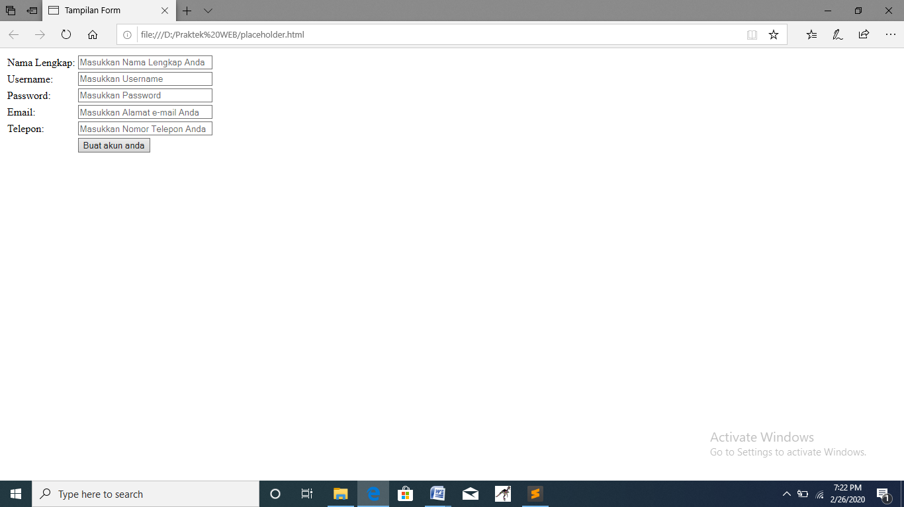

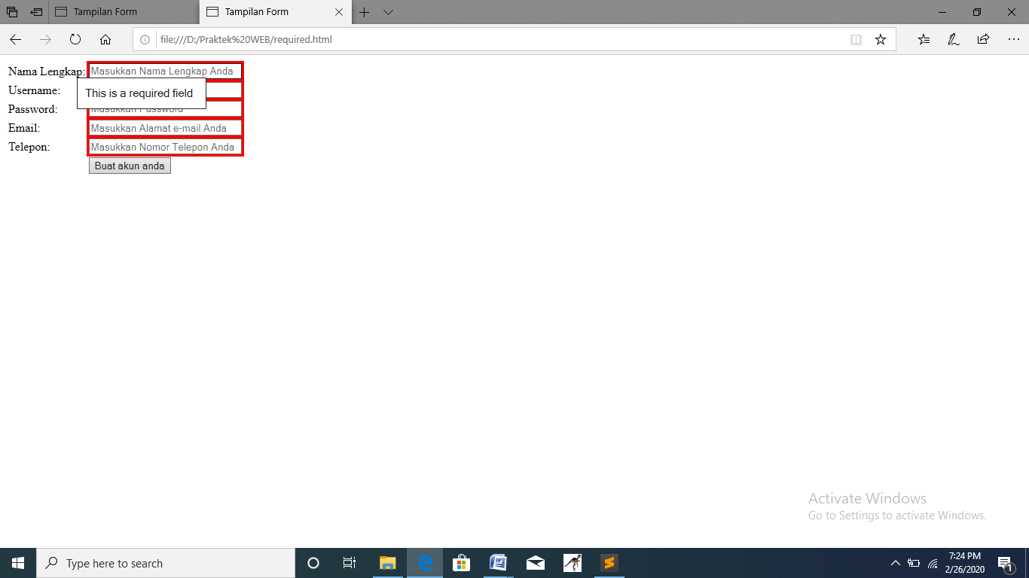

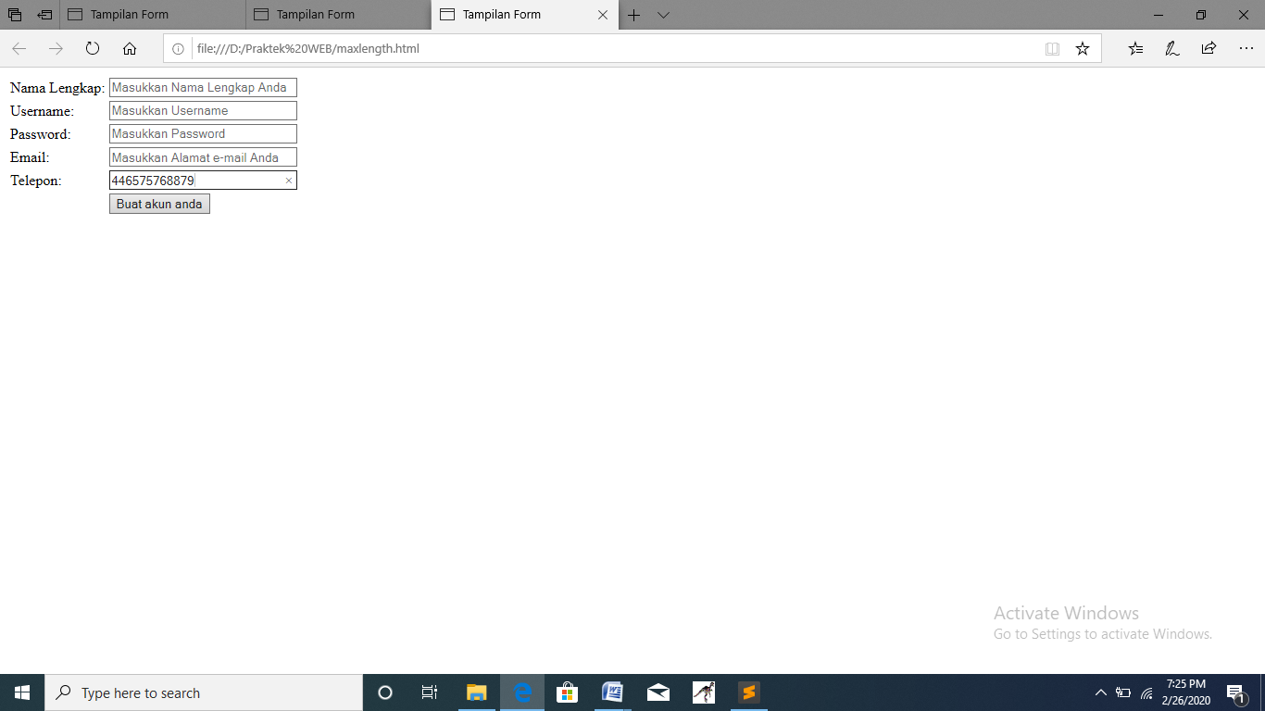

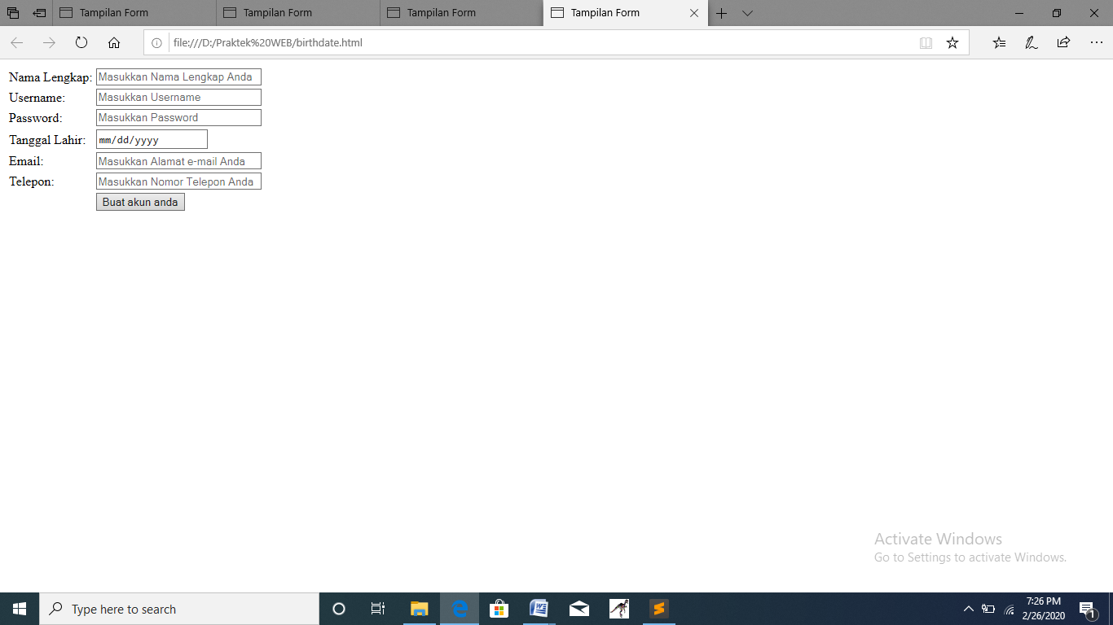

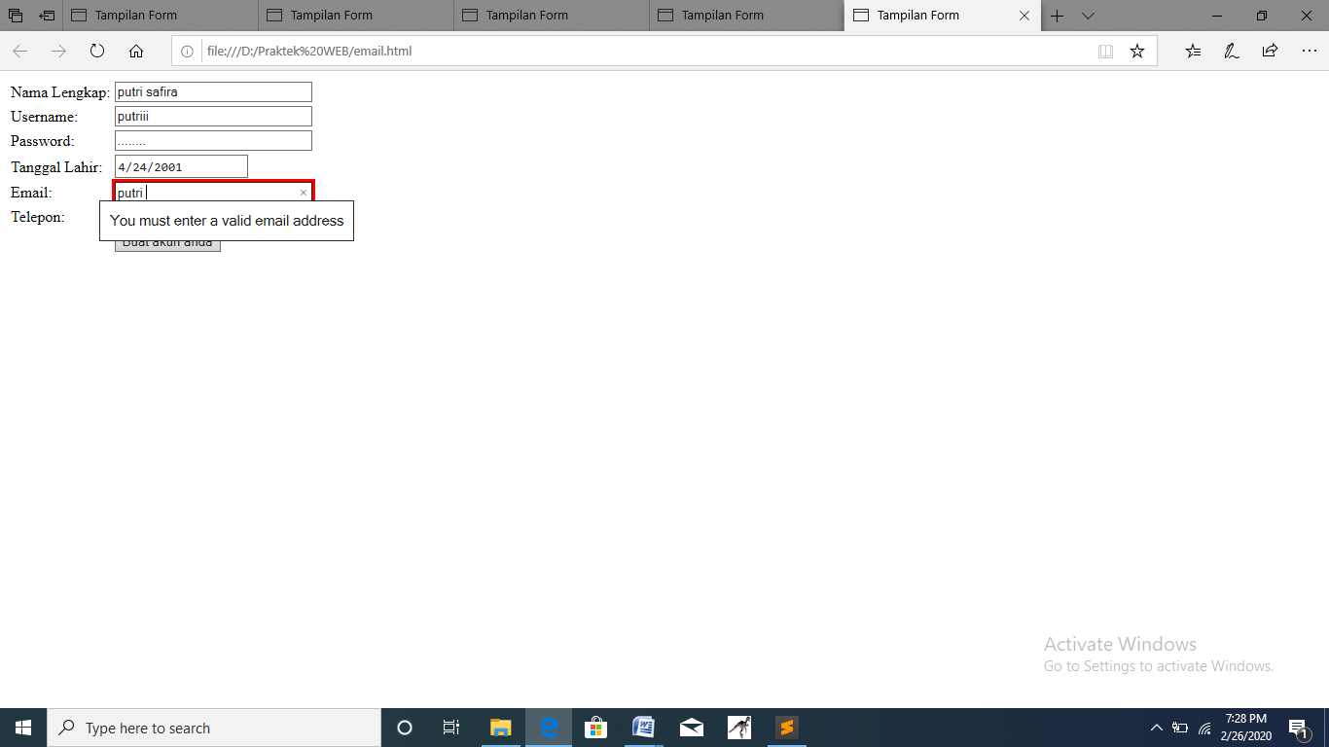

**D. Tugas Praktikum**

|  |
| --- |
| <!-- STUDI KASUS 4 -->  <!DOCTYPE html>  <html lang="en">  <head>  <title> Tampilan Form </title>  </head>    <body>  <h3> Studi Kasus: Validasi Input HTML5  <form action="" method="post">  <table border=0>    <tr>  <td> Nama Lengkap </td>  <td> :<input type="text" name="nama" placeholder="Isikan Nama Lengkap Anda" size="30" required />  </tr>    <tr>  <td> Usia </td>  <td> :<input type="number" name="nama" min="17" max="30" size="10" required /> (Usia min 17-30) </td>  </tr>    <tr>  <td> Email </td>  <td> :<input type="email" name="email" placeholder="nama_email@host.com" size="30" required />  </tr>    <tr>  <td> Web </td>  <td> :<input type="text" name="nama" placeholder="http://" size="30" required /></td>  </tr>    <tr>  <td> Password </td>  <td> :<input type="text" name="nama" min="8" placeholder="Semua karakter, min 8" size="30" required /> (Bonus) </td>  </tr>    <tr>  <td></td>  <td><input type="submit" value="Sumbit" required /></td>  </tr>    </table>  </form>    </body>  </html> |

